Student Name



**ST ALOYSIUS’ COLLEGE**

**2018**

*Final Examinations*

**Year 9 Commerce**

## Total marks – 80

**General Instructions**

* Reading time – 5 minutes
* Working time – 90 minutes
* Write using black or blue pen
* Write your Student Name at the top of this page, the multiple choice answer sheet, the start of every question in Part B, and Part C.
* Calculator allowed.

## PART A – Multiple Choice 20 marks

* Multiple Choice Questions 1–20
* Allow about 20 minutes for this section

## PART B – Short Answer 40 marks

* Attempt Questions 21–24
* Allow about 45 minutes for this section

## PART C – Extended Response 20 marks

* Attempt Question 25
* Allow about 25 minutes for this section

## PART A: Multiple choice (20 marks)

1. The process of arbitration determines that a decision made is enforceable by law and is therefore legally binding. Which organization arbitrates?
   1. Consumer, Trader and Tenancy Tribunal
   2. NSW Fair Trading
   3. Australian Securities and Investments Commission
   4. Australian Competition and Consumer Commission
2. Georgia works full time as a sales assistant at Glassons. Which of the following would be classified as a variable expense for Georgia?
   1. taxation
   2. rent
   3. loan repayments
   4. entertainment
3. Sam attended a lecture on “Comparison Shopping” and learnt many things about choosing what to buy in order to avoid wasting income. He wrote the following points down.
4. Investigate the product’s features.
5. Keep all receipts and invoices if purchasing a product.
6. Fix any problems by returning to seller if covered by warranty.
7. Think carefully about what you want.

The most correct order for deciding what to buy is:

1. 2, 4, 1, 3
2. 4, 1, 2, 3
3. 1, 2, 3, 4
4. 4, 2, 3, 1
5. “Bait and Switch Advertising” is an example of:
6. Get-rich-quick schemes
7. False/misleading advertising
8. Referral selling
9. Special offers
10. Which of the following does not reflect ‘ethical consumerism’?
11. Fairer trading conditions and opportunities for producers in developing countries.
12. A growing number of consumers choose to purchase products which are Australian made.
13. Some producers label their products GM-free.
14. The cosmetic industry is developing natural products not tested on animals.
15. A contract is legally binding if it has the following three essential elements:
    1. Product, offer, consideration
    2. Agreement, obligations, consideration
    3. Consideration, offer, approval
    4. Offer, consideration, acceptance
16. Matt is a sales representative for Aspen, a pharmaceutical company. He visits doctors, outlining the benefits of the company’s products. What promotional activity is Matt undertaking?
    1. Product placement
    2. Advertising
    3. Market research
    4. Personal selling
17. How can investors reduce their risks?
    1. Go for higher returns
    2. Invest in tobacco companies
    3. Diversify their investments
    4. Predict share market changes
18. Product Positioning can best be reflected by:
    1. A business satisfies the demand of their customers by offering an animal cruelty-free product
    2. An exclusive restaurant in Milsons Point offers full table service and an extensive menu
    3. Roger Federer is leaving his Nike sponsorship for a new deal at Uniqlo worth $300 million over the next 10 years
    4. Consumers prefer to select prepared meals from a supermarket or fast food outlet.
19. According to the idea of “risk and return”, the investment option which holds the greatest risk is:
    1. Property or real estate
    2. Balanced superannuation fund
    3. Share market
    4. Term deposit
20. What does the term **caveat emptor** mean?
    1. Let the buyer beware
    2. The right to choose
    3. The right to redress
    4. Money back guarantee
21. A source of income from the creation or invention of something new, such as writing a book or composing music is known as:
    1. Dividends
    2. Royalties
    3. Salary
    4. Profit
22. Christopher buys 1,000 Burroughs Ltd shares on 1st November 2016 for $65.00 a share. He sells all his 1,000 shares for $77.00 a share on 31st October 2018. No dividend payments are received by Christopher. What was Christopher’s annual rate of return over the past two years?
23. 7.8%
24. 9.2%
25. 15.6%
26. 18.5%
27. Which of the following is one of the four (4) basic rights of consumers?
28. Customers deserve the best deal available.
29. Consumer guarantees and warranties are honoured.
30. Refunds are justified if the consumer is not happy with the product.
31. Products are tested to be used by consumers for whatever purpose.
32. Coca Cola’s unique bottle shape is an example of:
33. Product enhancement
34. Product niche focus
35. Product development
36. Product differentiation
37. Which of the following actions by business could be considered an ethical strategy?
38. An energy company researching into environmentally sustainable forms of generating electricity.
39. A advertising company lobbying the Australian government to get rid of laws regarding the limited advertising of alcohol on TV.
40. The use of child labour in the production of cocoa by global chocolate companies to reduce costs.
41. A gambling company reducing the amount of money people can win from pokie machines.
42. A **wholesaler** can best be described as a business that:
43. Sells home-made goods at markets
44. Buys goods from consumers and sells to retailers
45. Buys goods in large quantities from manufacturers
46. Sells whole melons and other farm produce at market
47. A “2 for 1 offer” given by the school canteen for hash brown rolls would be considered as one of the following of the ‘4P’s’:
48. Price
49. Product
50. Promotion
51. Place
52. When an asset is deposited as a guarantee to fulfil the payment of a loan, the loan is called:
53. Secured
54. Unsecured
55. Personal
56. Credit
57. What is the best method to keep up-to-date records of payments and receipts?
58. Keep all the receipts in a box.
59. Scan receipts onto a computer.
60. Use a burroughs to make all the payments.
61. Record payments and receipts in a spreadsheet.

**Name**:

## PART C – EXTENDED RESPONSE SECTION (20 marks)

25. This question is based on the following information.

|  |
| --- |
| **Name:** Tom Greenfinger  **Age:** 28  **Occupation:** Environmental Engineer  **Education:** Bachelor of Advanced Science (Honours)/Engineering (Honours)(UNSW)  **Lives:** At home with grandmother and cat  **Owns:** A mobile phone, a car, (5 years old), Apple Mac Computer  **Income:** $110,000 (Full Time)  **Reason for Investing:** Saving for a deposit so he can buy an apartment/house in 3 to 5 years.  **Hobbies:** Gardening and playing Fortnite  **Associations:** Member of WWF, Australian Koala Foundation, Greenpeace |

As a Financial Adviser, Tom has asked for your advice on managing and investing his money. You are to write a report to present to Tom which will outline the following:

* Describe an investment portfolio and its purposes. In your answer, discuss all necessary elements to be included in the suggested portfolio.
* Suggest at least three (3) investment alternatives and explain the advantages and disadvantages of each.
* In addition to investment alternatives recommended, explain how Ethical Investment could be a positive investment option for this stage of Tom’s life. Recommend at least two(2) companies you could recommend could be part of Tom’s investment portfolio.

*Suggested headings: Introduction, Investment Portfolio, Investment Alternatives, and Recommended Investment Options including Ethical Investment (use such terms as positive/negative screening)*



## Name:

**PART B – Short Answers (40 marks)**

*Answer the following questions in the spaces provided.*

**Question 21 (10 Marks)**

**Consumer Choice**

25 May 2018 “**Australians warned to beware of phone scams”**

Australians are urged to be on guard against unscrupulous, unsolicited callers, claiming to represent the Australian Banking Association and asking for bank details to issue a ‘refund’, survey customer satisfaction or record banking history.

According to the ACCC every year 33,000 Australians are targeted by scammers in this particular way, with callers pretending to represent banks and other financial institutions, with recent estimates placing the cost to victims at over $4.7 million. This scam targeting the ABA is ongoing and was first reported in 2016. Banks often encounter this type of scam, with callers claiming to contact customers on their behalf.

Some of the techniques used by these scammers include:

Asking who you bank with, how long you have banked with them and your level of satisfaction

Asking for personal and banking details, including your name and driver’s licence number, bank account or credit card number, PINs or internet banking login

Telling people they are owed a ‘refund’ for overcharged bank fees but they have to pay a fee for it. They ask people to send money via post or Western Union.

Executive Director of Consumer Policy Christine Cupitt said that it was important customers remain vigilant against scammers even if they claim to be from reputable organisations such as banks or associations.

(<https://www.ausbanking.org.au/media/media-releases/media-release-2018/australians-warned-to-beware-of-phone-scams> Date Accessed: 02/11/18)

## What is a scam? (1)

## 

## __________________________________________________________________________

## __________________________________________________________________________

## __________________________________________________________________________

## __________________________________________________________________________

## Identify and describe three(3) other types of scams or “rip-offs”. (6)

## (i)__________________________________________________________________________

## __________________________________________________________________________

## __________________________________________________________________________

## __________________________________________________________________________

## (ii) __________________________________________________________________________

## __________________________________________________________________________

## __________________________________________________________________________

## __________________________________________________________________________

## (iii)__________________________________________________________________________

## __________________________________________________________________________

## __________________________________________________________________________

## __________________________________________________________________________

## 

## In 2011, a national consumer law known as Australian Consumer Law (ACL) was introduced in Australia. Outline three (3) main purposes of this law. (3)

## __________________________________________________________________________

## __________________________________________________________________________

## __________________________________________________________________________

## (ii) __________________________________________________________________________

## __________________________________________________________________________

## __________________________________________________________________________

## 

## (iii)__________________________________________________________________________

## __________________________________________________________________________

## __________________________________________________________________________

## 

## Name

**Question 22 (10 Marks)**

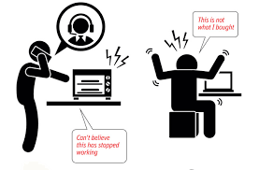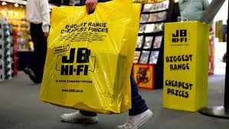**Consumer Choice**

Phil has just got home from a visit to John Bing-Lee Hi Fi to purchase a new laptop for school purposes. When opening up the box and removing the packaging, Phil has discovered that the laptop is damaged. He immediately goes back to the store and asks to see the manager. Phil explains the situation, however, the store owner does not believe it was damaged when it left the store.

(a) Explain the term “consumer redress”. (1) ________________________________________________________________________________________________________________________________________________________________________________________________________________________________________________

(b) Name two (2) federal government organisations that provide consumer assistance. (2)

(i) ___________________________________________________________________________

(ii) ___________________________________________________________________________

1. Your friend, Phil, has just contacted you for your advice regarding the situation he has found himself in following the purchase of a laptop from John Bing-Lee HiFi. Due to your knowledge of Commerce, you are able to advise him by setting out five (5) points he should remember in making a complaint. What are these? (5)
2. __________________________________________________________________________________________________________________________________________________________
3. __________________________________________________________________________________________________________________________________________________________
4. __________________________________________________________________________________________________________________________________________________________
5. __________________________________________________________________________________________________________________________________________________________
6. __________________________________________________________________________________________________________________________________________________________

(d) Explain “consumer guarantees” in terms of the *Competition and Consumer Act (2010).* (2)

________________________________________________________________________________________________________________________________________________________________________________________________________________________________________________________________________________________________________________________________

## Name

**Question 23 (10 Marks)**

**Promoting and Selling**

1. Outline the role of promotion in marketing. (2)

________________________________________________________________________________________________________________________________________________________________________________________________________________________________________________________________________________________________________________________________________________

1. Describe what is meant by a “promotional mix” and provide three elements to illustrate your response. (4)

________________________________________________________________________________________________________________________________________________________________________________________________________________________________________________________________________________________________________________________________________________

________________________________________________________________________________________________________________________________________________________________________________________________________________________________________________________________________________________________________________________________________________

**Refer to the Stimulus provided below.**

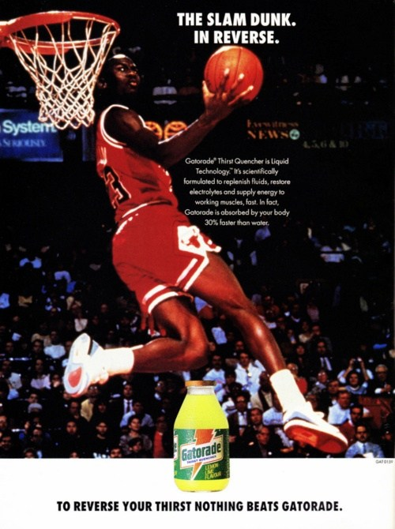

**(c)** With reference to the advertisement above, distinguish between what is meant by market segmentation and target markets. In your answer, identify primary and secondary target markets for this product. (4)

__________________________________________________________________________________________________________________________________________________________________________________________________________________________________________________________________________________________________________________________________________________________________________________________________________________________________________________________________________________________________________________________________________________________________________________________________________________________________________________________________________________________________________________________________________________________________________________________________________________________________________

**Question 24** **(10 Marks)**

**Personal Finance**

1. Explain the difference between saving and investing. (1)

___________________________________________________________________________________________________________________________________________________________________________________________________________________________________________________

1. Outline four (4) types of income**.** (4)

(i)__________________________________________________________________________________________________________________________________________________________________________________________________________________________________________________

(ii)_________________________________________________________________________________________________________________________________________________________________________________________________________________________________________________

(iii)_________________________________________________________________________________________________________________________________________________________________________________________________________________________________________________

(iv)_________________________________________________________________________________________________________________________________________________________________________________________________________________________________________________

1. “Responsible financial management does not mean the finer things in life are foregone.”

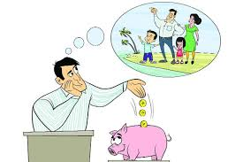

Discuss this statement in terms of the steps to be taken in budgeting. (5)

**Name**:

# YEAR 9 COMMERCE

**2018 Yearly Examinations**

**Answer Sheet**

## PART A: 20 Multiple Choice Questions (1 mark each)

*Place an 'X' in the correct box*

|  |  |  |  |  |
| --- | --- | --- | --- | --- |
|  | **A** | **B** | **C** | **D** |
| **1.** |  |  |  |  |
| **2.** |  |  |  |  |
| **3.** |  |  |  |  |
| **4.** |  |  |  |  |
| **5.** |  |  |  |  |
| **6.** |  |  |  |  |
| **7.** |  |  |  |  |
| **8.** |  |  |  |  |
| **9.** |  |  |  |  |
| **10.** |  |  |  |  |
| **11.** |  |  |  |  |
| **12.** |  |  |  |  |
| **13.** |  |  |  |  |
| **14.** |  |  |  |  |
| **15.** |  |  |  |  |
| **16.** |  |  |  |  |
| **17.** |  |  |  |  |
| **18.** |  |  |  |  |
| **19.** |  |  |  |  |
| **20.** |  |  |  |  |